

**Name: Syed Muhammad Fahad Fiaz**

**Roll No: BSSEM-S24-036**

**Section: SE 3A**

**Subject: Data Structure and Algorithms**

**Submitted To: Sir Rasikh Ali**

**Submission Date:**

**Assignment 13**

**DSA LAB TASK’S**

**LAB 13:** DFS and BFS

1. Insert and Traverse for DFS in tree

2. Insert and Traverse for DFS in graph

3. Insert and Traverse for BFS in tree

4. Insert and Traverse for BFS in graph

**Explanation:**

1. **DFS for Tree (Depth-First Search)t does:**

Creates a binary search tree

Inserts numbers in order (smaller left, bigger right)

Shows the tree contents using depth-first search (root → left → right)**How it works:**

**createNode**: makes new tree points

**insertNode**: places numbers in correct positions

**dfsTraversal**: prints nodes by going deep down each branch before backtracking

**Example Output:**  
50 30 20 40 70 60 80

**OUTPUT**

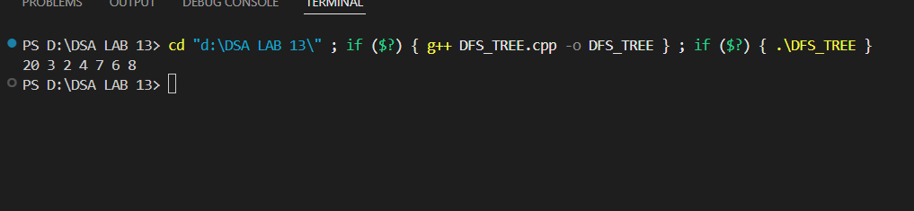

**2. BFS for Tree (Breadth-First Search)hat it does:**

Same tree structure as DFS version

Shows tree contents level by level (top to bottom, left to right**y difference:**

Uses a queue to track nodes

Processes nodes in the order they were discovered

Prints all nodes at current depth before moving deeper  
50 30 70 20 40 60 80

**OUTPUT**

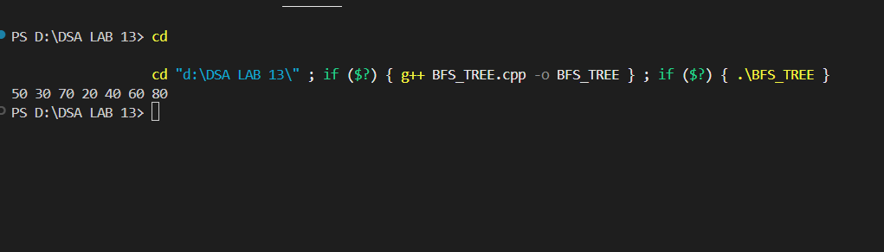

**3. DFS for Graph it does:**

Creates connections between numbered points (undirected graph)

Explores as far as possible along each branch before backtracking

Uses an adjacency matrix (grid) to store connections

Marks visited points to avoid cycles

Naturally follows one path until dead end  
0 1 3 4 2 5 6

**OUTPUT**

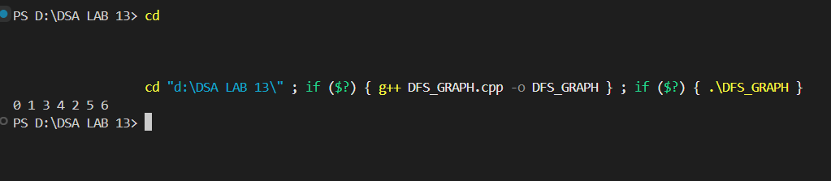

**4. BFS for Graph it does:**

Same graph structure as DFS version

Explores all neighbors at current depth before going deeper

Uses queue to process points in order

Always shows immediate connections first

Perfect for finding shortest paths  
0 1 2 3 4 5 6

**OUTPUT**

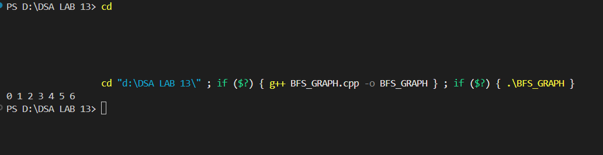

**DFS = Exploring maze by always taking left turns  
BFS = Searching house room-by-room (all doors on floor before going downstairs)**